**Demonstrate the Execution of sleep() and wait()**

**package** Pack3;

**public** **class** MyClass {

**private** **static** Object *LOCK* = **new** Object();

**public** **static** **void** main(String args[]) **throws** InterruptedException

{

Thread.*sleep*(1000);

System.***out***.println("Thread '" + Thread.*currentThread*().getName() + "' is woken after sleeping for 1 second");

**synchronized** (*LOCK*)

{

*LOCK*.wait(1000);

System.***out***.println("Object '" + *LOCK* + "' is woken after" + " waiting for 1 second");

}

}

}

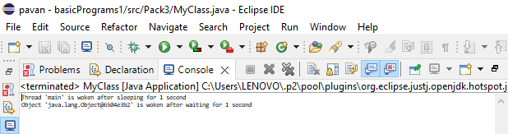

// Output: Thread ‘main’ is woken after sleeping for 1 second

// object ‘java.lang.Object@6504e3b2' is woken after waiting for 1 second